HEMANT SIROHI

hemant.srh@gmail.com | +91 952-953-3359

Driven Product Marketing Manager adept at SEO and integrated marketing illustrated across 12+ years of experience in related roles. Strategic and innovative with a passion for driving brand awareness and product performance.

# **Professional Experience:**

**1 May 2020 – PRESENT**

SEO Head

***TABSCAP Inc.***

Timely dispatch of periodical work reports to internal stakeholders in SEO projects. Optimize top performing content and provide recommendations that help enhance web content strategy.

**1 SEP 2020 – 06 Nov 2020**

SEO Specialist (Consultant)

***Exoways Web Technologies Pvt. Ltd.***

Strong growth/digital marketing skillset in a B2C or B2B2C environment (i.e. SEO, SMO, A/B testing, Google Analytics, Hotjar)

**4 AUG 2015 – 17 DEC, 2019**

Chief Marketing Officer (CMO)

***Education Culture Pvt. Ltd.***

SEO analysis, building and implementing media and marketing campaigns. Generating guidelines for building keyword specific content to meet client goals.

# **Education:**

**2012 - 2014**

MBA IN INFORMATION TECHNOLOGY

SHITAS

Uttar Pradesh, India

**2009 - 2011**

BACHELOR OF ARTS

MGSU

Rajasthan, India

# **References:**

**Mr. Ashish Arora**

Co-Founder

Infoshore Software Pvt. Ltd.

ashisharora83@gmail.com

**Mr. Rohit Khariwal**

Co-Founder & Director

Infoshore Software Pvt. Ltd.

rohit.khariwal@infoshore.biz

**Mr. Dev Garg**

Co-Founder & Director

Education Culture Pvt. Ltd.

devgarg@educationculture.net

**1 MARCH 2013 – 26 APRIL 2015**

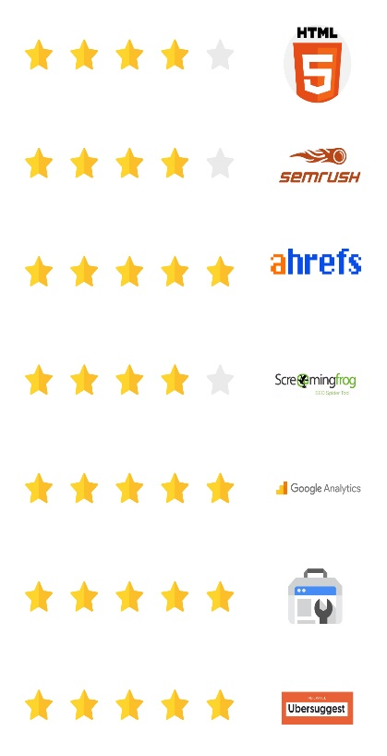SEO Team Head

***Ignis Way Infotech Pvt. Ltd.***

Team management. Websites evaluation with respect to keywords, page optimization & project progress.

**15 AUGUST 2010 – 27 FEBRUARY 2013**

Senior SEO Associate

***Infoshore Software Pvt. Ltd.***

SEO copywriting/editing, social media optimization and marketing to improve overall visibility. Leveraging web 2.0 technologies for corporate marketing efforts for various company portals.

**15 MAY 2008 – 1 MAY 2010**

SEO Associate

***Infoshore Software Pvt. Ltd.***

Recruiting, training and managing a team of SEO professionals. Develop and implement SMM strategies for various clients.

# **Software Skills:**

**Projects:**

[FourModules](https://www.fourmodules.com/)

[Assignment Help 4 Me](https://assignmenthelp4me.com/)

[Easy Gym Software](https://easygymsoftware.com/)

[Tabscap Inc.](https://www.tabscap.com/)

[SketchBubble](https://www.sketchbubble.com/)

[Presswala](https://www.presswala.co.in/)

[An Indian Affair](https://www.anindianaffair.com/)

And more than 35 projects.