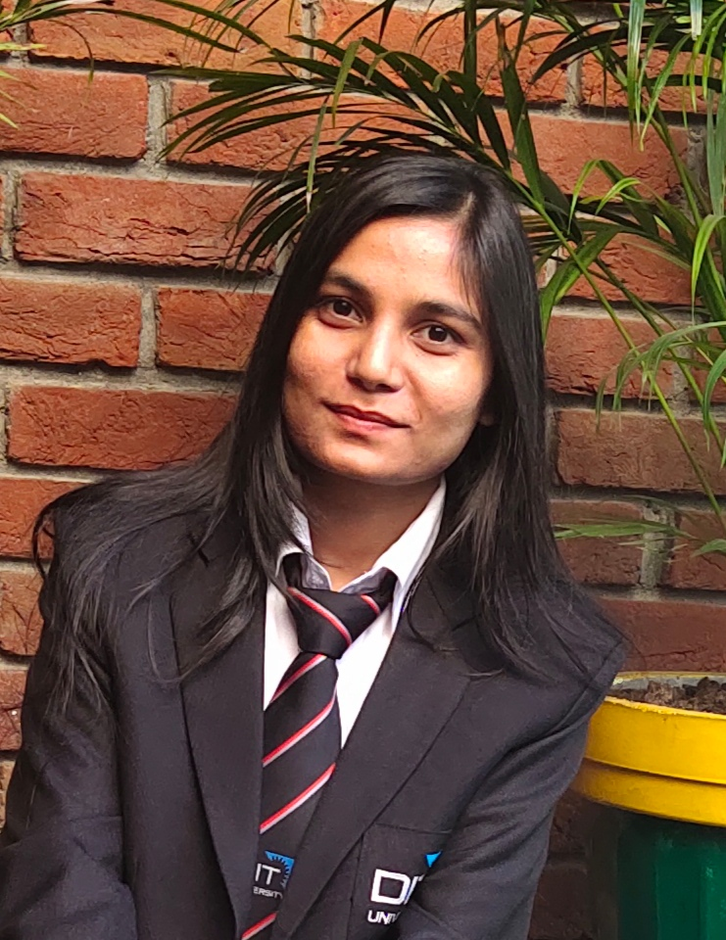 |  | Pratibha KuMAri  (Student)
PROFILE  To work for an organization which provides me the opportunity to improve my knowledge and skills to growth along with the organization objective.  Contact  PHONE:  8972781453  LINKEDIN:  https://www.linkedin.com/in/pratibha-rai-a64574160  EMAIL:  pratibharai499@gmail.com  Hobbies  Travelling  Love to Play Volleyball |  | EDUCATION  DIT University, Dehradun (Pursuing)  MCA(2019-2021)  CGPA : 8.21  Durgapur Institute of Advance Technology and Management(DIATM)  BCA (2016-2019)  CGPA : 8.5  Kendriya Vidyalaya no.1 AFS Jorhat, Assam  12th (2015-2016)  Percentage : 60.02%  Kendriya Vidyalaya Kohima, Nagaland  10th, (2013-2014)  CGPA : 9.2  Training  CETPA [core JAVA and advance Java]  2 June 2018 – 15 July 2018  I had done training for learning purpose in Dehradun when I was in BCA and I got certificated after successfully completion of training.  InterNship  Coursera [JAVA FOR ANDRIOD]  26 July 2020 – 29 August 2020  This was an online internship and I made project at the end of internship and got certificate.  Work Experience  College Project [The Quiz Application by Using Android]  15 September 2020 – 22 Nov 2020  In this project, I was a group leader and we were 4 members. I handled that project in a very good manner.  Technologies involved are Android studio, android SDK, java, xml, SQLite.  College Project [ Easy Docs Meet]  15 September 2018 – 20 Dec 2018  This was a group project and I worked as a front end developer.  Technologies we use HTML,CSS, PHP, My SQL.  skills  JAVA  Android  My SQL  HTML  CSS  PHP  Achievements  Participated in many cultural programs at School Level.  Selected in Cluster level social science Exhibition.  Core Committee member at School level.  First position secured in Long Jump.  Second position secured in 200 meter Race.

