Experience
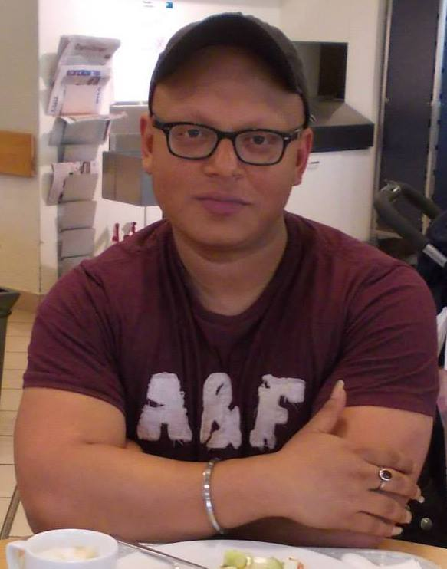
ratnabir Guha
Senior Content producer/senior copy editor
hindustan times

SUMMARY
Editor and writer with 6+ years of experience in print and digital media

Skills & Abilities
Editing, Writing, Proofreading, Digital Marketing, Social Media Optimization, Search Engine Optimization, Corporate Communication

Contact

Flat 702/Tower N, Logix Blossom Greens, Noida 143B
MOBILE: 8335994077
Email: ratnobir82@yahoo.co.in
https://www.linkedin.com/in/ratnabir-guha-4a728168/

Hindustan times

June 2018 onwards

CTC 8.15 LAkh PER ANNUM
- Edit and rewrite news articles, feature articles and guest columns for the City Pages of Hindustan Times
- Coordinate with reporters, freelancers, contributors, post-production, image and design teams of the paper
- Meet production deadlines on a daily basis
- Ideate and brainstorm content ideas for the pages
- Publish edited copies online on a real-time basis

teletext holidays, Noida

JUNE 2017- May 2018
CTC: 6.5 LAKH PER ANNUM
- Write blogs, articles, travel guides and hotel descriptions for the website
- Edit and rewrite existing web content
- Knowledge of the best SEO practices in the industry
- Create content for landing pages and bespoke pages for the website
- Closely work with the image team for picture research for the website
Sample Links:
https://www.teletextholidays.co.uk/blog/7-open-air-markets-our-bucket-list
https://www.teletextholidays.co.uk/blog/paris-food-6-ways-eat-your-way-around-city

Crystal Hues Pvt Ltd, Noida

jan 2017 to june 2017
- Produce original content for Crystalhues.com and IndiaisUs.com
- Produce content and ad copies for CHL’s clients
- Manage, edit and curate articles and blogs written by freelancers
- Edit and improve existing content
- Collaborate and partner with relevant organizations for IndiaisUs to generate increasing traffic and improve ranking.
Sample Link:
https://www.facebook.com/Indiaisus/

The Telegraph, ABP Pvt. ltd, kolkata

March 2015 to jan 2017
- Copyedit and proofread opinion pieces, feature stories, letters to the editor, book reviews and art reviews
- Design, edit and manage Edit, Op-ed, Books and Art Review pages of the newspaper
- Experience with Quark Express
- Work within strict deadlines
- Handle production and post-production work.
Sample Links:
https://www.telegraphindia.com/1161115/jsp/opinion/story_119152.jsp
https://www.telegraphindia.com/1160707/jsp/opinion/story_95163.jsp

ABSAS SOLUTIONS, Kolkata

2014 to 2015
- Write blogs, articles, emailers and white papers for the website
- Knowledge of on-page and off-page optimization
- Ideate and strategize content for the website.

TODAY’S TRAVELLER, NEW DELHI (CONSULTANT)
June 2018-July 2020
- Handle the website and all social media portals of Today’s Traveller
- Bring out 2 monthly B2B magazines, Today’s Traveller and Lifestyle Living, till March 2020
- Handle external communications of the company’s event vertical, OPTIMICE EVENTS
- Edit annual coffee table book, Today’s Traveller

Education

JAWAHARLAL NEHRU UNIVERSITY
- M.PHIL AND PhD IN MODERN INDIAN HISTORY

UNIVERSITY OF CALCUTTA

ma in history

Presidency University

Ba in history

REFERENCES

ANURADHA VARMA, DELHI

CONTENT MANAGER, TELETEXT HOLIDAYS
9350171278, anu.varma@gmail.com

NILUTPAL THAKUR, DELHI

SENIOR ASSISTANT EDITOR, HINDUSTAN TIMES
9311744983, nilutpal.thakur@hindustantimes.com

