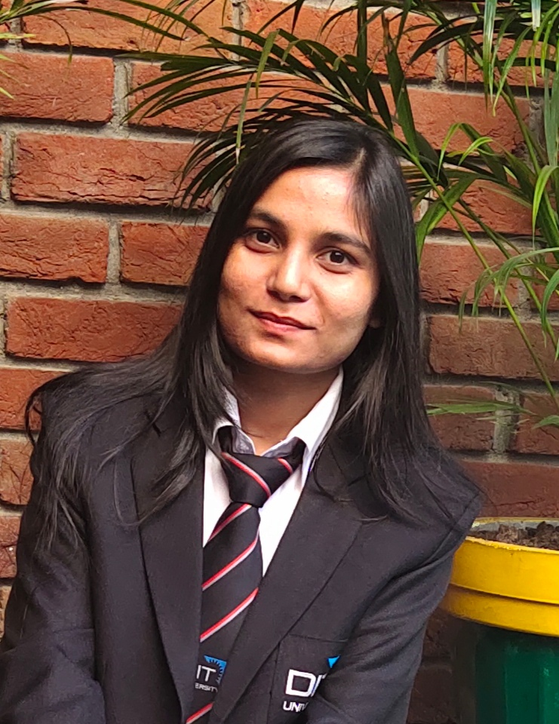 |  | Pratibha KuMAri  (Student)
PROFILE  To work for an organization which provides me the opportunity to improve my knowledge and skills to growth along with the organization objective.  Contact  PHONE:  8972781453  LINKEDIN:  https://www.linkedin.com/in/pratibha-rai-a64574160  EMAIL:  pratibharai499@gmail.com  Hobbies  Travelling  Love to Play Volleyball  skills  JAVA  Android  HTML  CSS  Linux  PHP |  | EDUCATION  DIT University, Dehradun (Pursuing)  MCA(2019-2021)  CGPA : 8.21  Durgapur Institute of Advance Technology and Management(DIATM)  BCA (2016-2019)  CGPA : 8.5  Kendriya Vidyalaya no.1 AFS Jorhat, Assam  12th (2015-2016)  Percentage : 60.02%  Kendriya Vidyalaya Kohima, Nagaland  10th, (2013-2014)  CGPA : 9.2  Training  CETPA [core JAVA and advance Java]  2 June 2018 – 15 July 2018  I had done training for learning purpose in Dehradun when I was in BCA and I got certificated after successfully completion of training.  InterNship  Coursera [JAVA FOR ANDRIOD]  26 July 2020 – 29 August 2020  This was an online internship and I made project at the end of internship and got certificate.  Work Experience  College Project [The Quiz Application by Using Android]  15 September 2020 – 22 Nov 2020  In this project, I was a group leader and we were 4 members. Technologies involved are Android studio, android SDK, java, xml, SQLite.  College Project [Easy docs Meet]  15 September 2018 – 22 dec 2018  In this project, we are 4 members. It was the group Project. I had done HTML CSS and database part of the project. For backend, PHP was Used.

