HARSHIT SRIVASTAVA  Harshitsanu12@gmail.com  +91 7839246012  H.No.3339, Sector 19-D, Chandigarh- 160019  https://www.linkedin.com/in/harshit-srivastava-a72068a7 | 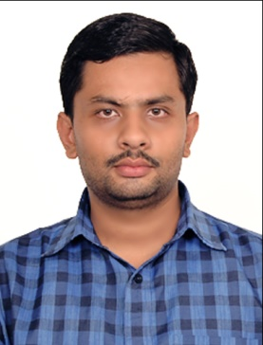
CAREER OBJECTIVE:
To work with an organization with a professional groups for career development and who give me the opportunity for professional growth and career advancement .Willing to work as a key player in challenging and creative environment.
EDUCATIONAL QUALIFICATION:

Examination/ Degree | Institute | Specialization | Passing year | CGPA/%
MBA | VIT, Vellore | OPERATIONS&IT(major)  FINANCE(minor) | 2020 | 7.19
B Tech | VBSPU, JAUNPUR | Information Technology | 2012 | 66.76%
12th | LHK Study Centre, Varanasi | Science | 2008 | 59.2%
10th | LHK Study Centre, Varanasi | Maths, Science, English, Social Science, Hindi | 2006 | 68%
SUMMER TRAINING:
Industry | Brief Description | Period
BSNL ALTTC | IP Addressing | 6 June 2011 to 1 July 2011
BSNL ALTTC | Network & Cyber Security | 3 June 2019 to 2 July 2019
WORK EXPERIENCE:
Industry | Designation | Period
STRYDO Technologies  Private Limited | Web Developer | 25 June 2012 to 25 June 2014
CERTIFICATION:
Institute | Course | Performance | Period
NISM | Mutual Fund Distributor | 54/100 | 12 September 2019
GRAS | Tally |  | 9 February 2017 to 7 April 2017
NIIT | Professional Skills, Critical Thinking and Creative Problem Solving, Capstone Project, Android, HTML5, JSF, Hibernate, Spring, C++, Java, RDBMS & T- SQL, Servlets and JSP |  | 18 March 2015 to 10 June 2016
PROJECTS:
Organization | Title | Period
STRYDO Technologies  Private Limited | Sentiment analysis on customer feedback data: product reviews | 1 February 2020 to 24 April 2020
ACHIEVEMENTS:
Certification | Brief Description | Date
NIIT YUVA JYOTI | Bridging Module | 1 June 2015
MEMBERSHIPS:
Organization | Brief Description | From
AIMA | Student Membership | 1 October 2012
TECHNICAL SKILLS:
Operating System : Windows 7, 8 &10
Languages : C, C++, java, html 5
Software : MS Office, SQL Server 2012, Tally
PERSONAL DETAILS:
Date of Birth : 23/11/1989
Father’s name : GAURI RATAN SRIVASTAVA
Language Known : English, Hindi
Nationality : Indian

DECLARATION:
I hereby declare that all the information mentioned above is true to the best of my knowledge.

Date: 01-11-2020
Place: Chandigarh HARSHIT SRIVASTAVA

