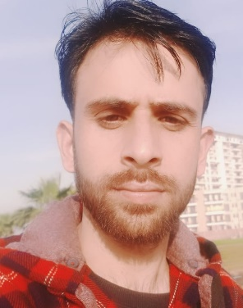

Name: Imran Ali

Contact: +91 7006045057

Email: imranalikmr@outlook.com

**Profile Info**

A dynamic and multitalented professional with exceptional knowledge in both Written & Verbal communication skills, my professional skills in Communication and with my passion for the field of Mass communication and journalistic writing will help me grow as an asset for your organization. Looking for a long term full time job where I can apply my extensive skills and knowledge to the position for which I am hired. I am very excited about the opportunity to make an immediate and valuable contribution to your company.

**Educational Qualification**

|  |  |
| --- | --- |
| 12th in Arts Stream | Govt. Boys Hr.Sec School, Litter, Jammu & Kashmir |
| Bachelors in Arts (B.A) | Govt. Boys degree college, Budgam |
| Masters in English Literature | Punjab national university, Chandigarh |
| Master in English | IGNOU |

**Professional Skills**

|  |  |  |  |
| --- | --- | --- | --- |
| **Critical analysis** | **Logical thinking** | **Written Expression** | **Oral expression** |
| **Presentation** | **General awareness** | **Content writing** | **Advertisement creation** |
| **Email writing** | **Planning & Research** | **Grammatical editing** | **Administration** |

**Soft Skills**

|  |  |  |  |
| --- | --- | --- | --- |
| Leadership | Time Management | Team Work | Self-Motivation |
| Adaptability | Communication | Resilience | Persistence |
| Self-Confidence | Growth Mindset | Emotion Regulation | Presentation |

**Interests**

* Reading books – Novels, Poetry and plays.
* Reading about all the latest developments in the field of English literature.
* I Enjoy Swimming as it helps me in refreshing my mind.
* I Volunteer Annually at Blood Donation Camps Set up by Different Organizations both in & Outside J&K.
* Frequent Blood Donor.

**Personal Details**

Name: Imran Ali

Contact: 7006045057

Email: [imranalikmr@outlook.com](mailto:imranalikmr@outlook.com)

Address: Nickloora, Litter, Jammu & Kashmir, 192305

D.O.B: 04/07/1996

\***Thank you for the time and effort you take when reviewing my application.**

Best Regards,

Imran Ali