**CURRICULUM VITAE**

**NAME:-** Avinash Thakur

**E-mail:-**avinash.thakur.5473@gmail.com

**Phone No:-** +917009738791, +918988519055

**Permanent Address:-** Vill. Jamsai, Tehsil & P.O. Sarkaghat, Distt. Mandi (H.P.) 177042

**Current Address:-** Sector 32 Chandigarh

**PERSONAL DETAIL**

**Father’s Name:-** Mr. Suresh Thakur

**Mother’s Name:-** Mrs. Nagisha Thakur

**Date Of Birth:-** 23/03/1993

**Nationality:-** Indian

**Marital Status:-** Married

**Languages Known:-** English & Hindi

**OBJECTIVE**

As a public relations and marketing professional with significant experience of 3 years as a Digital Marketing Analyst in SEO enhanced copywriting and content management, I've become an expert in a variety of fields, including social media management and networking & blogging. Possess excellent problem-solving and analytical skills. To thrive on professional credential and seek a challenging job in a reputed organization and to integrate my skills, Internet Marketing skills in IT industry especially to excel in the field of Digital Marketing.

**EDUCATIONAL QUALIFICATION**

|  |  |  |  |
| --- | --- | --- | --- |
| **Qualification** | **University/Institute/Board** | **Year** | **Marks Obtained (%)** |
| B.A | Kalinga University | 2015-2017 | 73% |
| ITI{Diesel Mechanic} | Indra Gandhi Industrial & Vocational Training, Sohna | 2012-2014 | 74.58% |
| 12th | H.P Board of School Education | 2011 | 71.5% |
| 10th | H.P Board of School Education | 2008 | 62% |

**Work EXPERIENCE**

|  |  |  |
| --- | --- | --- |
| **Name of Company** | **Position Held** | **Period** |
| **Prologic Technologies** | Digital Marketing Analyst | 03.07.2018 to 31.03.2019 |
| **World Com Solutions** | Sr. Seo Executive | From 08.01.2018 to 30.06.2018 |
| **Websoftrix** | Seo Executive | From 03.12.2016 to 05.01.2018 |

**Skills :**Search Engine optimization, Marketing, Content Management, Branding, Content Development, Social Networking, Campaign Management, Development, And Social Media Management.

**Search Engine Optimization Skills**

|  |  |
| --- | --- |
| * On-page SEO * Off-site SEO * Analytical Skills * SEO Editing Skills * Guest Posts * Meta & Header Tags * Weekly Monthly Reports To Clients * Site-Map * Boosting Ranking * Article Submissions * Web2.0 * Infography Submissions * Directory Submissions * Website Optimization | * Webmaster * Analytic Reports * Keyword Research * Schema Markup * Competitor Analysis * Robot.txt * Target Audience Analysis * Content Strategy, Development, Planning * Image Optimization * Domain Management and Strategy * Url Optimization * Link Building * Image Optimization * Classifieds Posting * PPT & PDF Submission |

**Social Media Skills**

|  |  |
| --- | --- |
| * Facebook Posts * Instagram Posts * Twitter Posts * Linkedin Posts * Keyword Research * Youtube Channel Handling | * Facebook Ads * Instagram Ads * Content Strategy of Posts * Target Audience * Competitor Analysis |

**Google Adword Skills**

* Set and Run Google Adword Campaigns as per client requirements

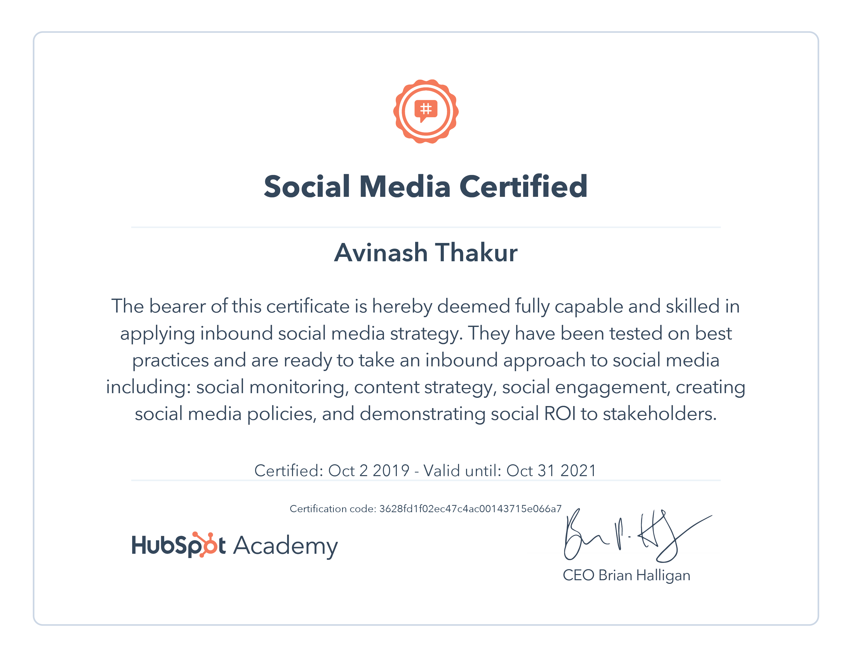

**Description:**

* Educate clients on best local search practices to improve upon existing SEO strategies.
* Research keyword trends via Google analytics, Google webmaster tools and Google trends.
* Provide clients with strategic recommendations to improve organic search performance.
* Perform research based on trending topics and keywords related to client goals and events.
* Write, edit, and manage both internal blogs and client blogs using current SEO standards and best practices
* Develop social media content calendars and editorial guides to enhance client’s social presence.
* Create social media profiles, page promotions, contests, and other CTA.
* Publish trending content based on current events and industry happenings.
* Provide clients with best practice recommendations of social media utilization.
* Develop custom reports based the on client’s ongoing reputation performance.
* Managing the implementation, tracking, and measurement of social media ad campaigns targeted at specific audience segments for views, engagement, and follower campaigns on all key products.
* Found highly-searched and uncompetitive keywords to dominate Google positions #1-3.
* Updating all web pages surrounding scholarships by working with the content team to create blogs, design.
* Optimization (SEO) to improve organic research and click-through rate (CTR).
* Already Handel many clients and 5 people team.

**COMPUTER SKILLS**

Good knowledge of MS(Office, Power Point & Excel).

Good typing speed.

**DECLARATION**

I do here by declare that all the information given above is true and best of my knowledge and believes.

**DATE:-______________**

**PLACE:-_____________**