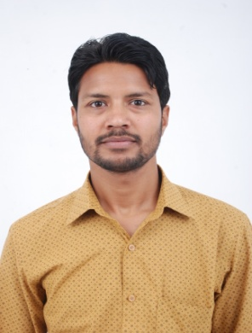Kuldeep

Mobile: 9878844442

E-Mail: [kuldeep.25october@gmail.com](mailto:kuldeep.25october@gmail.com)

**OBJECTIVE:**

To secure a challenging career that provides me with consistent professional and personal growth and an opportunity to contribute significantly toward achieving organization’s mission.  
  
**WORK EXPERIENCE:**

1**. Organization:**  **SEOWHIZZ (Now** is**SprintRise Digital Academy);** Mohali. Job profile includes complete organic and ethical SEO and optimizing client as well as company's website with keywords for Search Engine ranking.

**Designation:** SEO Executive

* **Duration:** October 2016 – October 2017 (1 Year)

2**. Organization:**  **Netsterz Infotech Pvt. Ltd.;** Mohali.

Job profile includes managing all SEO activities such as content strategy, link building, and optimizing copy and landing pages with keyword strategy to increase rankings on all major search networks.

**Designation:**  SEO Executive

* **Duration:**  February 2018 – March 2020 (2 Years & 1 Month)

**SKILL SET:**

* Software Development
* Web Development
* Coding
* Internet Marketing
* Client Servicing

**TECHNICAL SKILLS:**

* HyperText Markup Language (HTML)
* Cascading Style Sheets (CSS)
* JavaScript (JS)
* Search Engine Optimization (SEO)
* Object-Oriented Programming

**SOFT SKILLS:**

* Proactive
* Self-starting
* Creative
* Adaptable

**DESIRED CAREER PROFILE:**

* Seeking an entry-level web development trainee (intern) or as a web developer fresher job to explore and enhance my technical knowledge gained in HTML, CSS, and JavaScript.
* Organized and Hard-working learner looking to take advantage of my proven skills to meet business needs of an organization.

|  |  |  |
| --- | --- | --- |
| 1 | Industry | Software/ Web Development Services |
| 2 | Functional Area | IT Software - Client Server / MEAN Stack Web Development / Full Stack Web Development |
| 3 | Role | Fresher/Trainee |
| 4 | Job/ Employment Type | Full Time |
| 5 | Expected Salary | As I am just starting my career, You can offer me a package that would suit a beginner like me. I would accept anything that is at par with market standards as well as remains suitable for my job level. |
| 6 | Location | Tricity (Chandigarh, Panchkula, Mohali) |

**ACADEMIC CREDENTIALS:**

|  |  |  |  |  |
| --- | --- | --- | --- | --- |
| **Sr. No.** | **Examination** | **Passing Year** | **Board/University** | **Percentage** |
| 1 | 10th | 2005 | CBSE | 62.7% |
| 2 | 12th | 2007 | CBSE | 55% |
| 3 | BCA | 2010 | PTU (DEP) | 67.3% |
| 4 | MCA | 2015 | PTU | 68.8% |

**PERSONAL PROFILE:**

Name Kuldeep

Father’s Name Sh. Tarsem Kumar

Address H.No. 196, New Darshani Bagh, Manimajra, Chandigarh

Date of Birth 25/10/1988

Nationality Indian

Languages Known Hindi, English and Punjabi

**DECLARATION:**

I hereby declare that the above information furnished is true to the best of my knowledge and belief.

**Place:** Chandigarh

**Date:** (Kuldeep)