BRIJESH SINGH

AUGUST 20, 2019

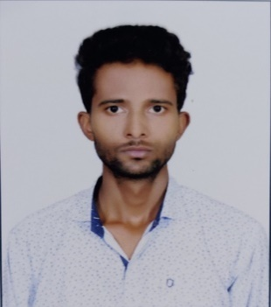 | BH1, GJUS&T  HISAR-125001  8397052478  brijeshsingh7272@gmail.com

Objective

I aspire to become a Software Engineer

Education

Degree/Diploma | Year of passing | Collage/Uni./Board | % Achieved
B.Tech(CSE) | 2020 | GJUS&T | 62%
12th | 2015 | HBSE | 75%
10th | 2013 | HBSE | 90%

TRAININGS
Internet of Things(IOT), ECSI in collaboration with IBM, HYDRABAD
- Development of IOT Smart technologies using arduino Board.
- Developed a project on “SMART CITY” using different type of sensors

TECHNICAL SKILLS
- C/C++
- knowledge of Data Structure And Algorithms

achievements
- Awarded with a District level NSS Camping Certificate
- Represented my School in District Level QUIZ “Bharat Ko Jano Pratiyogita”

hobbies and interests
I Love playing and Watching Cricket,
Reading and Listening Music

