**6 months internship experience in HTML, CSS, Php and WordPress from Oceana Tech, Mohali Ruchi** 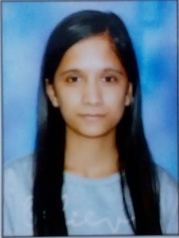

Call Me-9915186307

Mail Me- [thakurruchi584@gmail.com](mailto:thakurruchi584@gmail.com)

**Objective-**

* To work for an enterprise with great ethics and excellent work experience.
* To be punctual, obedient and quick learner.
* To be consistent learner and remain obedient to my seniors.

**Education-**

|  |  |  |  |  |
| --- | --- | --- | --- | --- |
| **Course** | **Institute** | **University/Board** | **Year of passing** | **Percentage** |
| BCA | Degree College Hamirpur | HPU | 2017 | 68% |
| 12th | JNV Dungrin, Hamirpur | CBSE | 2014 | 71.8% |
| 10th | JNV Dungrin, Hamirpur | CBSE | 2014 | 78% |

**Technical Skills-**

* 6-month internship experience in Php
* 6-month internship experience in HTML, CSS
* 6-month internship experience in WordPress
* Knowledge of MS Word, MS Excell and MS Power point

**Soft Skills-**

* Communication Skill
* Team Work
* Time Management
* Leadership Quality

**Job Responsibilities-**

Working with team members to achieve targets set forth for the process delivery.

**Personal Information-**

Father’s Name: Pawan Kumar

D.O.B: 03/02/197

Gender: Female

Marital Status: Unmarried

Language: English & Hindi

Nationality: Hindi

Religion: Hindu

Address: VPO- Dudhana, Teh-Galore, Distt- hamirpur(H.P.)177026

**Declaration-**

I do hereby declare that above mentioned information is true to the best of my knowledge and belief.

**Place:** Hamirpur

**Date:** 11-07-2020

Yours truly,

(Ruchi)