RESUME

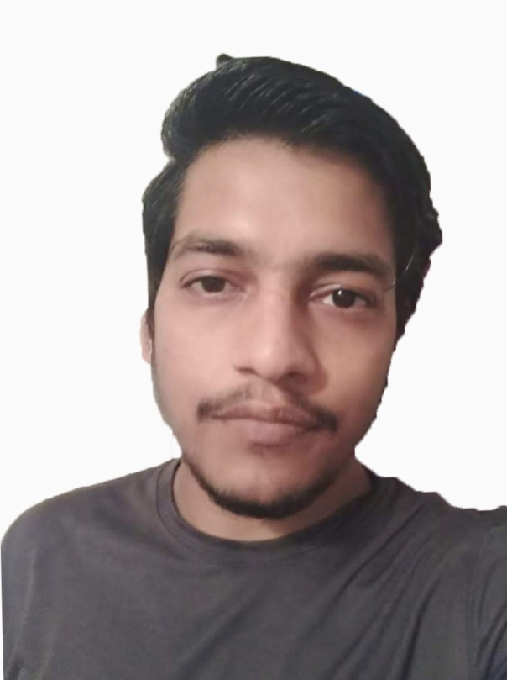

**Kumar Kishlay Phone no**:8054099256

S/o Satyendra Narayan Singh **Email:krkislay27@gmail.com**

#1102, 11th flr, Kendra vihar 2

Sunny enclave Mohali

**Career objective**:

To pursue a challenging career that will recognize and utilize my potentials and provide me the opportunity to use my technical, analytical and innovative ideas to achieve organizational as well as personal growth.

**Academic Details:**

* **10th,**Passed through CBSE.
* **DIPLOMA (EE)**Passed through PSBTE.

**Personal Strengths:**

* Optimistic and Adaptable.
* Hardworking
* Ability to work cooperatively in group with good communication skills
* A fast learner, possessing the right blend of Analysis and technology skills.
* Good people skills ability to communicate effectively and build long lasting/ mutually beneficial relationships.
* Great Interest in Fitness.

**Experience**

* 8 Months as fresher
* 14 Months worked with Expinator Web Technologies
* Currently working with Chunky Brains

**Personal Particulars:**

* **Date of Birth : 28 Dec.1994**
* **Languages** : Punjabi**,** English & Hindi
* **Gender :** Male
* **Nationality :** Indian
* **Marital Status :** Unmarried
* **Hobbies :** Listening music, reading, Travelling

**Skills**

SEO(On-page, Off-page, Keyword optimization), Keyword research, Content marketing, Copy writing, Landing page optimization, Adobe Photoshop.

**Declaration:**

Hereby I declare that the above statements are true to the best of my knowledge and belief and I bear the responsibility for the correctness of the above mentioned particulars.

**Date: Kumar Kishlay**