
Abhinav Rana

REACT JS DEVELOPER ~ FRONT END DEVELOPER~ JAVASCRIPT DEVELOPER
Expertise in analysis, design implementation / debugging skills/ deployment of business applications
abhi.rana0786@gmail.com +91-7009141309
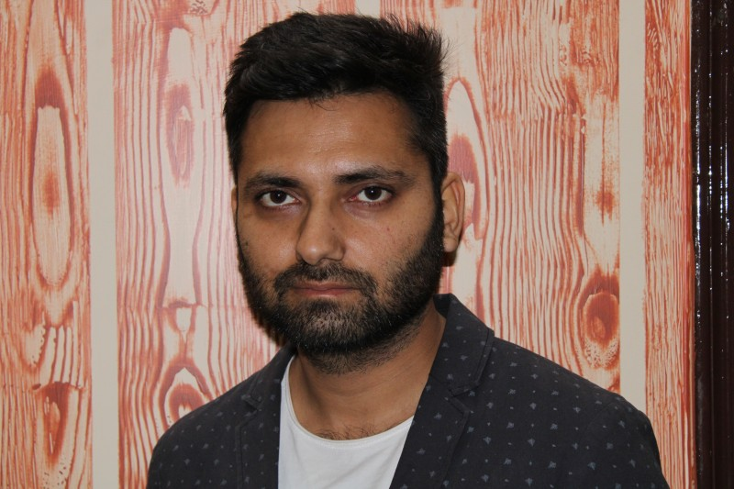

Profile Summary
- A young and enthusiastic team player with 6 Years of extensive work experience in the fields of study, analysis, design, implementation and deployment of modern business applications. I seek an intellectually stimulating and challenging position in knowledge based organization where I can use my knowledge to achieve best results
- An accomplishable analyst with success implementing management solutions that improve business functionality with reducing cost, increased performance and positively affecting the bottom line.
- Experienced in writing requirement specifications and functional and technical design documents, user presentations and user trainings.
- Have excellent Communication, Interpersonal, Analytical and Debugging skills.
- Currently working as Technology Analyst with Firminiq Systems Pvt Ltd. having 6 years of experience in HTML5, CSS, JQuery, Javascript, Bootstrap and have more than 1 year of experience in React JS.

Core Competencies  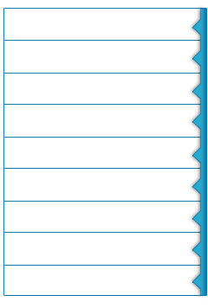  Front End Development  Requirement Analysis  User Presentations  Technical Design Documents  Design Implementation  Debugging Skills  Team Building & Leadership  Agile Methodology  Unit Testing |  | Organizational Experience  Firminiq Systems Pvt Ltd., Chandigarh from Nov’19 – Present as Technology Analyst  Projects Title  1. Nursing App  Client : Nursing App  Environment : Bootstrap, React.JS, Redux, HTML and CSS  Description : This is Hospital Management System based on the locations where Personnels and Patients have been added and assigned to various locations by Admin . It includes two types of USER Role i.e. Admin and Personnel. Each Personnel can view the details of patients assigned to it and administer the medicine and update the records and check about patient history.  2. Slots Ambassador  Client : Slots Ambassador  Environment : Bootstrap, React.JS, Redux, HTML and CSS  Description : This is based on Online Gambling Site which includes different Casinos having various Slots that includes third party url where user can play and also have Articles/News Section for different authors. Implemented Redux for Managing the state of website and followed the techniques to increase its performance.  NetParticipate Solutions Pvt. Ltd., Mohali from Aug’17 – Aug’19 as Sr. Web Developer  Projects Title  1. Hitachi CX Portal  Client: Hitachi  Environment : Bootstrap, React.JS, HTML, JavaScript and CSS  Description : Hitachi Case Manager Tool includes assessing, planning, implementing, monitoring and evaluating actions required to meet the Customer support. Worked on Creating and Integrating Components using React.JS with Form Validations and Routing.  2. DigiCert  Client : DigiCert  Environment : Bootstrap, Adobe Target, JavaScript and CSS3  Description : DigiCert, a leading global provider and cyber security provider which offers Website Security Solutions and related PKI solutions.  Worked on Adobe Target for DigiCert Website Personalization and created other HTML Pages.  Infosys Ltd.(Under the payroll of Infosys BPO Ltd.), Chandigarh from Oct’15 – Aug’17 as Technology Specialist- UI  Projects Title  1. Adidas  Client : Adidas  Environment : HTML5, Java, JavaScript and CSS3  Description : It includes Consumer Portal Module where user can register, subscribe and purchase the products using their own account worldwide including many countries. It offers shoes, clothing and accessories etc. This website is globally known worldwide and targets mobile devices and web.
Skill Set


CSS
HTML5
React JS
JavaScript
Career Timeline  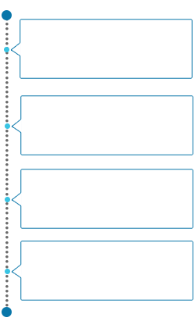  Nov’19 – Present  Firminiq Systems Pvt Ltd., Chandigarh  Aug’17 – Aug’19  NetParticipate Solutions,  Mohali  Dec’12 – Sep’15  A1 Technology Pvt Ltd.,  Mohali  Oct’15 – Aug’17  Infosys Ltd.,  Chandigarh  Kalium, Dubai as Logistics & Supply Chain Consultant  Academic Details  - B.E. (Computer Science) from Lovely Professional University, Jalandhar, in 2012 with 62% | A1 Technology Pvt Ltd., Mohali from Dec’12 – Sep’15 as Software Developer  Projects Title  1. American Homes  Client : American Homes 4 Rent  Environment : Phonegap  Description : It offers rental homes that have been renovated and maintained  to their standards. This Application includes multiple User Roles i.e. Bidder, Inspector and Admin. Depending upon the roles, the user can bid as well as inspect the properties for various counties offline as well as online in Application  2. Juniper  Client : Juniper Networks  Environment : HTML5 with Bootstrap and JQuery  Description : Juniper delivers high-performance, scalable, and integrated solutions for securing networks, applications, and access to data across the entire enterprise network ecosystem. It provides Customer Support which includes Case Manager Tool including Case details and RMA details available to the end user. Juniper Order Status module includes Product details, Shipment details, Start date, End date, Warranty Date and Services etc.  3. RVO Clinical  Client : Revision Optics  Environment : HTML5, JQuery and ISpring Pro 7  Description : The Raindrop Near Vision Inlay is a microscopic hydrogel inlay that is designed to correct presbyopia.It is based on mobile-ready video presentations on Eye Care and Raindrop with the tool - ISpring Pro 7 for PowerPoint in HTML5 based Application.  4. Autographics  Client : Autographics Inc.  Environment : Adobe Flex Builder 3  Description : VERSO an integrated library system (ILS) is designed to help libraries manage their resources while significantly improving patron information discovery and service delivery. It meets the requirements of library systems ranging in size and composition from a single branch library to diverse multi-branch.  5. Slowmag  Client : Slowmag  Environment : Phonegap  Description: This Application is about Slow-Mag magnesium chloride dietary supplement which is one of the best ways to get the magnesium you need. Created user-flow, wireframes and related documentation about it. Worked with visually impaired users to make sites highly accessible, even with AJAX.
Personal Details
Date of Birth: 1st December 1989

