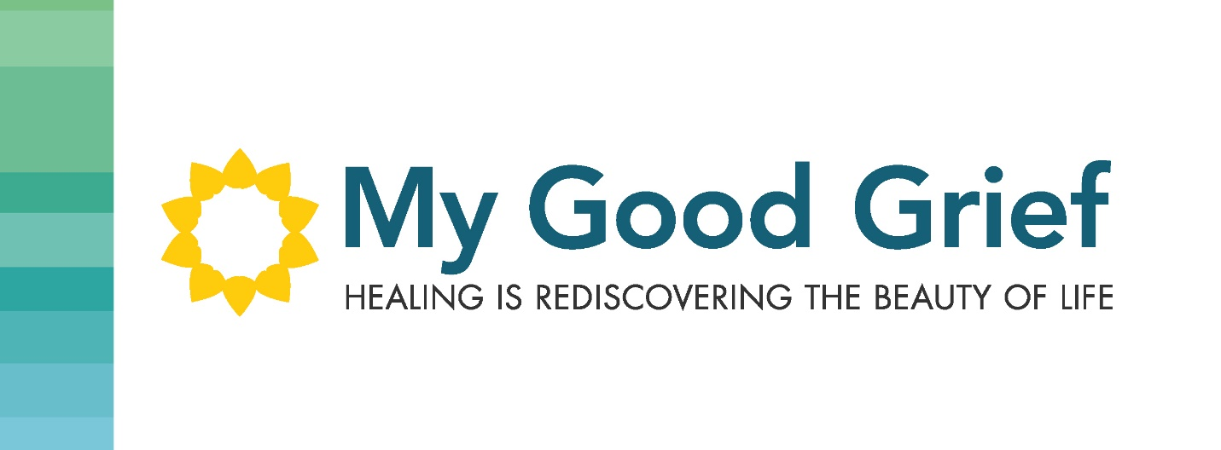

Stepping Stone 7 – Moving from pain to love

There may be more thoughts on your heart that need to be expressed. Once you have taken the time in Stepping Stone 7 to document and communicate them, my hope is that you are able to feel a shift that will allow you to walk forward without the pain. Please understand the grieving never ends, you will always miss your loved one and will always hold the experience of the circumstance that you are grieving, in your heart, but you can move forward without the pain of it stinging you and holding you back from experiencing love and vitality in your heart.

You can now be open to integrating the loss into your life to move through the process. The reward for leaning into the pain is that the pain subsides, and you can fill the void with love. Looking toward the future and letting go of the pain from the past can allow new things, new thoughts, new actions and new experiences, into your life.

I applaud and congratulate you for taking this courageous journey into healing. Often what happens when people open up the door for healing, they get curious on what is down deeper to heal in themselves. This could be your first glimpse into knowing there are hurts. Perhaps there were things you wrote about during the 7 Stepping Stones, that you want to explore further. There is always more healing available as our hearts are expansive and our hurts can be deep and old. If you are someone that wants to continue the healing journey and you want to take a deeper look into your loss, I have an online program that is for you.

This will allow you to take your healing to the next level. Explore questions that are still lingering in your head and in your heart. You will receive my interactive workbook that will guide you through this journey (Value $30). You will also receive 9 corresponding videos with some extra guidance through the process (Value $299). As a BONUS I will also offer a half hour coaching call with me (Value $150). This is a total of $479 worth of healing tools.

As an acknowledgement for doing the work you have already done, through the 7 Stepping Stones to reclaiming your life after loss and the subsequent email information to guide you through the process, I will offer the online program for $67.00.

I can accept e-transfers and we can get started right away to heal your heart and have you free from the pain that is holding you back in life.

I am honored to be a part of your journey.

Cheryl