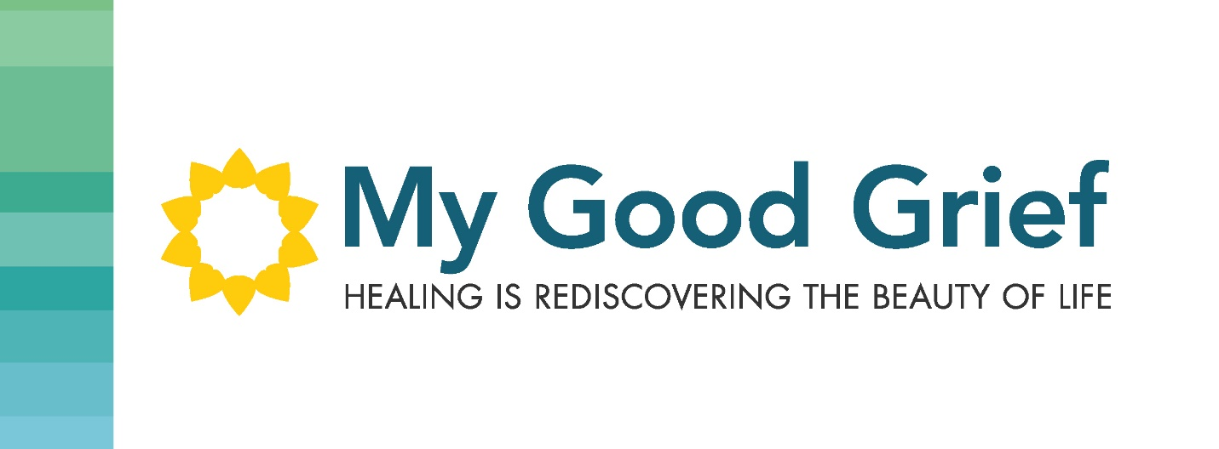

Stepping Stone 6 – Make room for more love

This can feel very scary, and it’s much deeper than the cliché of “Letting Go”. It’s actually allowing the pain to leave and freeing up room for something else. It can feel like you are replacing the pain which is representing your loved one or the circumstance you’re hurting over, with something else.

We can hold onto the pain as if it is holding onto them or justifying us in some way or proving our love. Holding onto this pain does not make us right and does not make us more loving. It is closing us off to other love that we currently are not open to.

Letting go of the pain actually allows their love to take up more space in our hearts. Love is infinite and expandable. We are actually contracting our love by holding the pain and taking up space in our hearts. If we can let go of the pain, our hearts are free to allow more love in and that can be filled with the love of our loved ones, and other forms of love that we didn’t even see because of the pain taking up all the space.

This might be in your blind spot and can be difficult to see on your own, but could be revealed by taking part in my online program and walking through the interactive workbook which is the guideline I use, when facilitating my 8 week workshop with my clients. The questions are thought provoking and allow you to look in those blind spots and explore your heart to find joy that you didn’t even think was possible. It will reveal to you where you need healing and give you the access to heal, so that you can return to your life with new vitality, and leave the pain behind you. You will see what is holding you back and be able to move forward with new insights. Feel whole and free again.

The workbook is written in an analogy of walking through a forest. You start out in darkness, and through a guided process, you start to see the dappled light between the leaves in the trees, and continue your walk until you eventually see the sunshine and the beauty in your life again.

The videos can help guide you and highlight where to concentrate your efforts, with some tips and tricks as you move through the chapters, and through your healing.

Grief will change you if you allow it. What will you allow it to change in you? What will you let in?

Cheryl