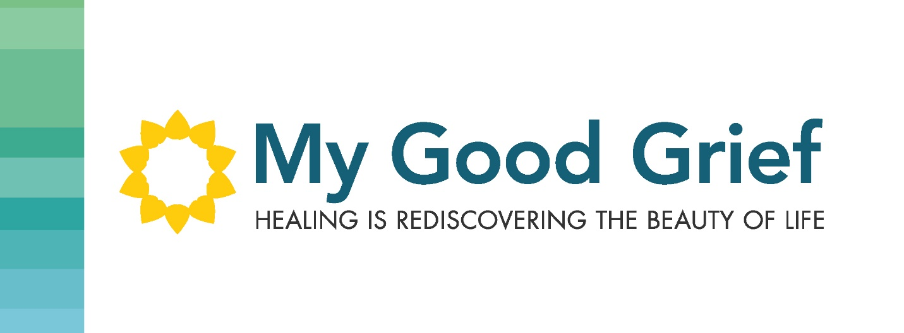

Stepping Stone 5 – All you need is Love

This journey takes so much courage and I applaud you if you are still with me, in this process. It is never easy to go into our pain and open our hearts to it. We have programmed ourselves to stuff this pain deep inside and our coping strategies assist us with it quite well, and from the outside, we can function and be productive in our lives. But you know, and I know, that what is going on inside is completely different than what it looks like outside. You are hurting.

I encourage you to stick with this, and keep your heart open to allow the healing to happen. You may notice you need to actually have someone to walk with in this journey depending on how painful it is for you. I am here for you and I am willing to stand shoulder to shoulder with you hand in hand while you do this work. I offer one on one coaching face to face, or via video conference or audio. I also have an online program that offers a workbook for you to work through independently with guidance videos to assist you to walk through this journey into your heart.

This is not a journey to take alone. Please find support for yourself so that you can do this work and find freedom and joy in your heart. Once people start looking, they often want to do the exploration and work through the My Good Grief workbook with the associated videos guiding them through the process.

It will require kindness with yourself. Please be patient with yourself as you do this work. Don’t ever forget about you, while doing this work. Forgiveness is such a huge gift to yourself and remember it is sometimes about forgiving yourself. If we can muster up the courage to forgive others, then let’s give ourselves the same level of grace. Forgive you!!

Cheryl