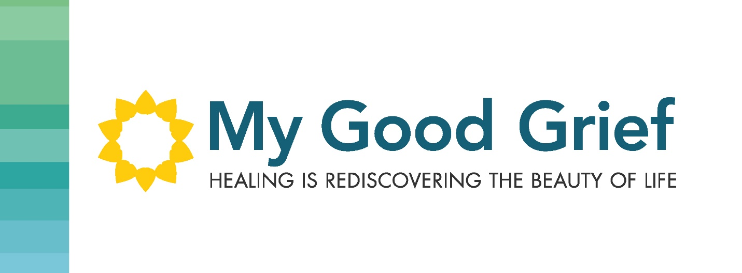

Stepping Stone 4 – The good news and the bad news

When we hold others responsible for our circumstances, it makes us a victim and leaves us stuck. We could leave ourselves stuck forever, hoping and wishing that someone else, or some circumstance changes, in order for us to have peace and joy in our hearts.

This can be the bad news because we have wanted to see, hear, and witness or experience changes in behaviors from someone, or want a particular circumstance to change. Me telling you this might not happen, can be very discouraging. We can feel defeated and feel like giving up. It can feel like you will never be happy then, as a result.

But what if you were actually in charge? I know if you were in charge, you would make them change their behavior or you would change the circumstance. But, here’s the thing, everything you have done so far has not changed it or you would not still be in the pain.

So perhaps you can be willing, to try this out.

You’ve probably heard all the cliché’s around this. “You can only change you”, “Let it go”, “Just ignore them”, “Who cares about them”, “Choose to be happy”. Easier said than done. I am not saying to ignore any of the behavior and I’m certainly not asking you to harden your heart and not care about them or the circumstance. The behavior or circumstance is very real for you. I am saying feel the pain, and know that you can take responsibility for how you RESPOND to the circumstance or behavior.

That circumstance may never change and that person may never change their behavior, but are you really committed to staying in the pain or staying unhappy? I hope not, or you wouldn’t be seeking some healing in this area.

What if you could just own 1% of the responsibility and that 1% is how you respond to it. That’s a start.

Once we take ownership, we can be the one in charge of how it goes from this moment forward. As long as you are at the effect of it, it is depending on something, or someone, to change. But if we are at the root cause of it, then we can feel like we are in the driver’s seat. That is the good news. Wouldn’t you like to be back in the driver’s seat of your life?

Try it on….

Cheryl