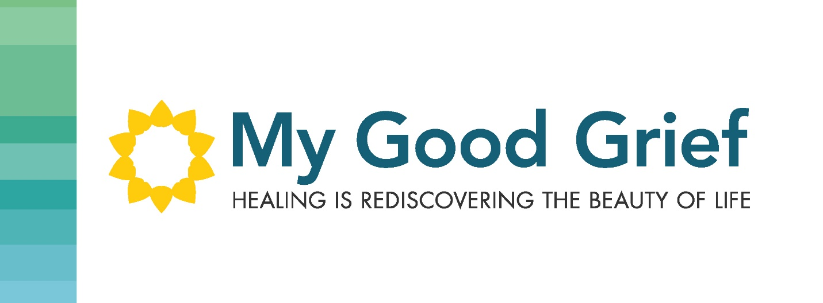

Stepping Stone 3 – Should they stay or should they go?

Coping Strategies are learned at a very young age when we start experiencing loss. We mirror our parents and the other influential people in our lives. They serve us, to frame our thoughts and be able to function and continue to be productive in our lives while we juggle the stresses of life.

So how do you tell whether your coping strategies should stay or if they should go? If your coping strategies support you in your mental health by giving you a healthy outlet and a break from the stresses of your day and they “give” to you, then then should stay. However, if they are consuming you, helping you avoid dealing with something, aiding you in “checking out” for extended periods of time, helping you to numb your pain, then perhaps they are not serving you to move forward, but instead, they could be helping to keep you stuck in your pain, and you might find yourself feeling like you need them to survive. That’s a sign that perhaps it is time to do a reset.

You know you, the best, and you know what is best for you. Perhaps you need to step back and be still, sit in silence for a while, to reflect on what you really need. The answers are inside of us if we take the time to stop and listen.

All of our coping strategies can serve us to a certain extent, and as they say, “everything in moderation”. It’s only when they start to consume us that it starts to be unhealthy and you can be the judge of that.

Cheryl