**SFL Issues**

1. The blog page's search box is not working.

<https://www.salesforlife.com/blog/>

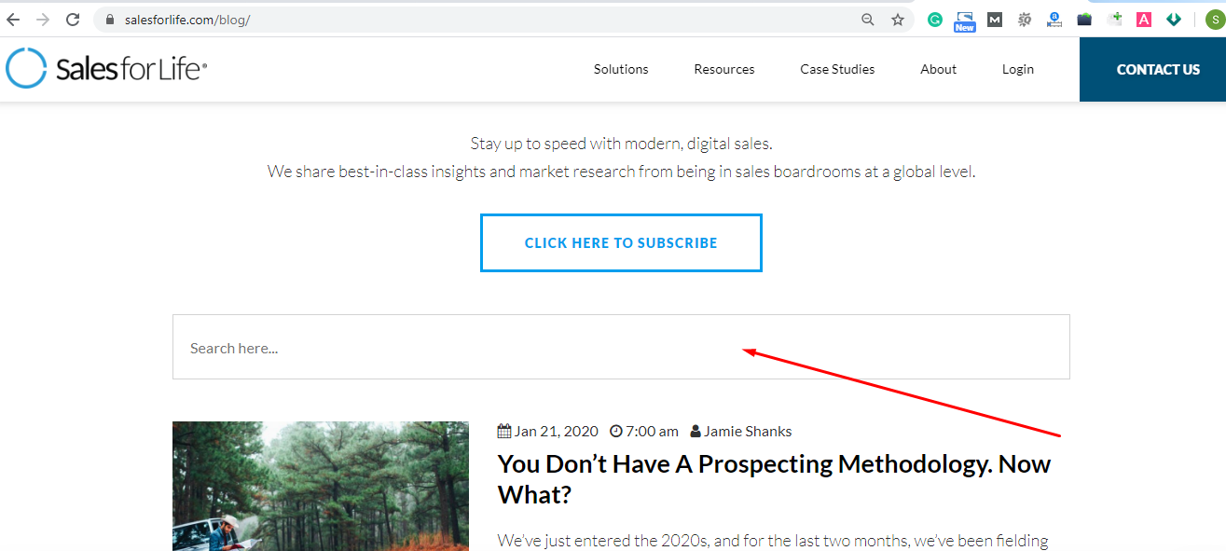

1. The video frame width is wider than the screen.

<https://www.salesforlife.com/blog/baby-steps-for-social-proximity/>

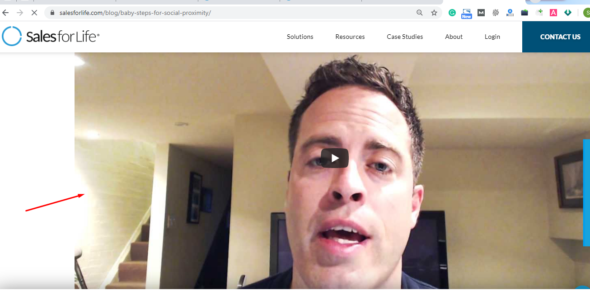

1. The Video is not playing.

<https://www.salesforlife.com/blog/forget-dos-and-donts-of-social-selling-its-all-fair-game/>

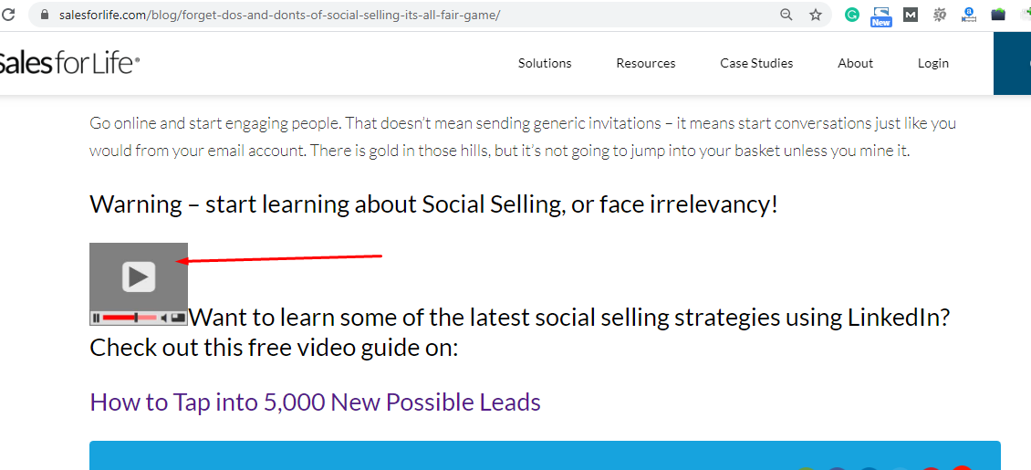

1. The Video frame’s height and width are too small.

<https://www.salesforlife.com/blog/redefining-the-account-selection-process-ai-summit-june-2018/>

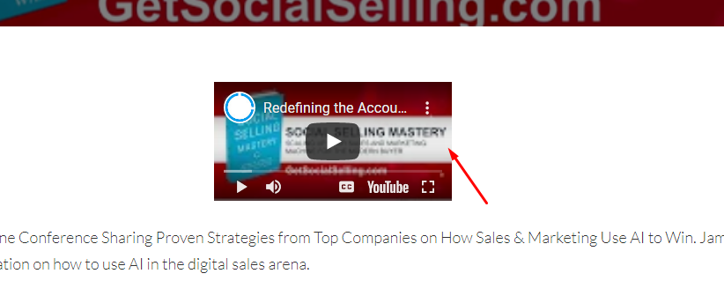

1. Need to create the custom 404 page.

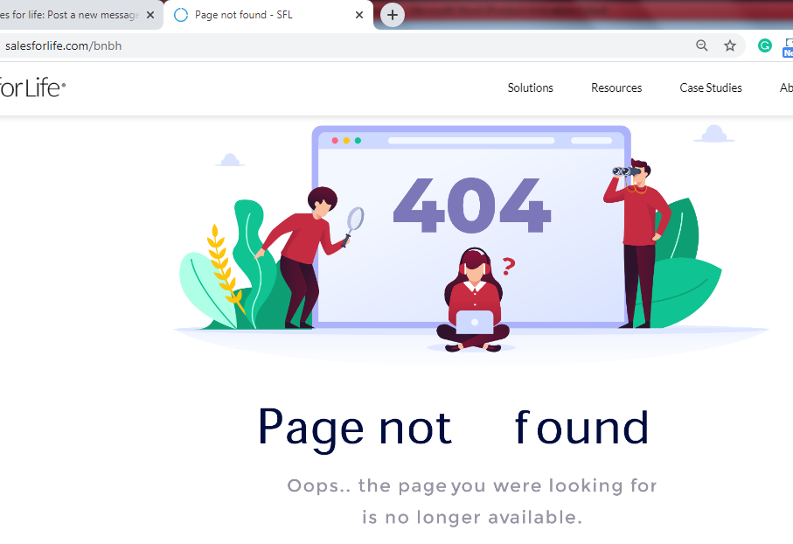

1. A Podcast is missing in this blog: <https://www.salesforlife.com/blog/lets-talk-sales/>.

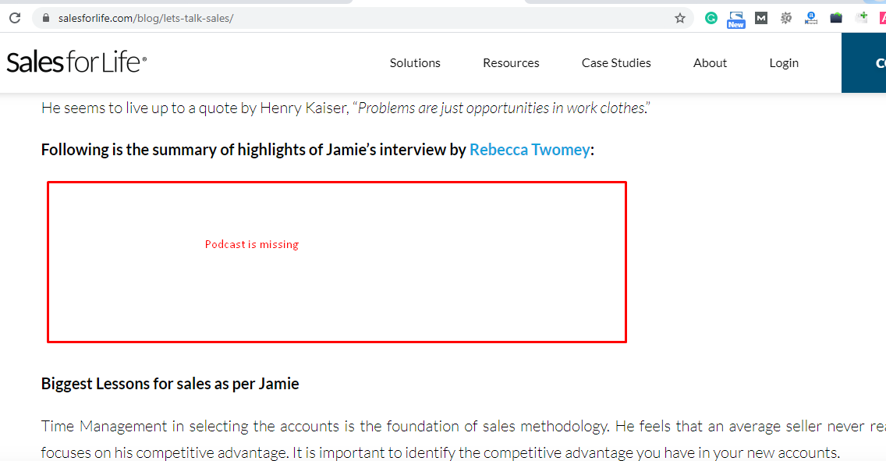

Need to add a podcast. Please open the attached url for the Podcast reference: <https://criteriaforsuccess.com/lets-talk-sales-interview-with-jamie-shanks-episode-149/>

1. Image wider than screen on Mobile.

<https://www.salesforlife.com/blog/your-sales-teams-crazy-to-not-use-salesloft/>

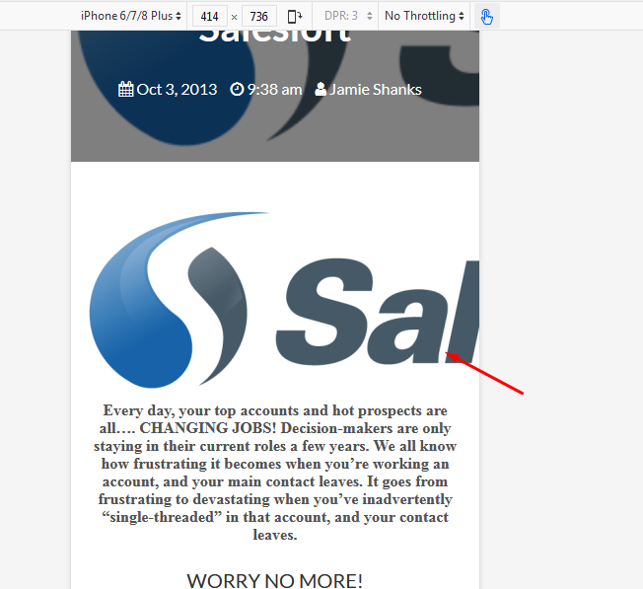

<https://www.salesforlife.com/blog/how-live-chat-on-your-website-can-improve-sales/>

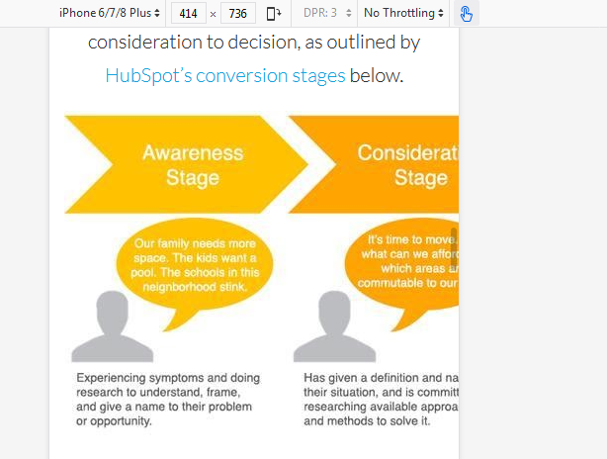

1. The following URLs are not mobile-friendly. Please check:

<https://www.salesforlife.com/blog/top-5-linkedin-infographics-for-social-selling-pros/>

<https://www.salesforlife.com/blog/how-live-chat-on-your-website-can-improve-sales/>

<https://www.salesforlife.com/blog/are-you-social-selling-ready/>

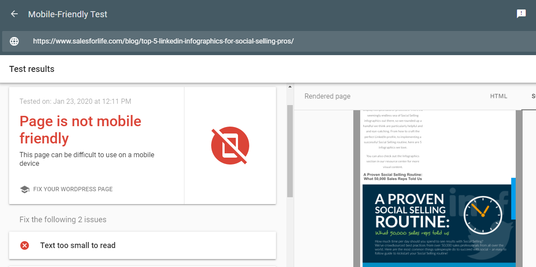

1. Videos are not showing properly on Mobile. Please check the following URLs:

<https://www.salesforlife.com/blog/the-road-to-4000-linkedin-connections/>

<https://www.salesforlife.com/blog/todays-b2b-buyer-demands-a-frictionless-buying-experience/>

https://www.salesforlife.com/blog/a-recipe-for-failure-when-sales-leadership-fails-to-embrace-change/

